**USER GUIDE**



*A place for refugees to find a temporary home*

Contents

**Der blev ikke fundet nogen elementer til indholdsfortegnelsen.**

# Main page

When entering the system for the first time, you will be presented with the following page.

If you are already registered as a user of the system, select *Login*, or select *Register* if you want to register an account.

# Registration

Selecting *Register* takes you to the registration page. Here you will need to select the type of account you want to register for:

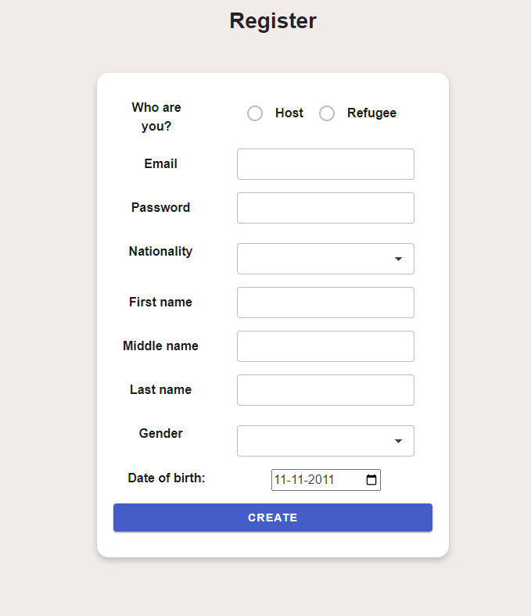

After selecting the type of account you wish to apply for, you will need to fill in your personal information as shown on the screen.[1]

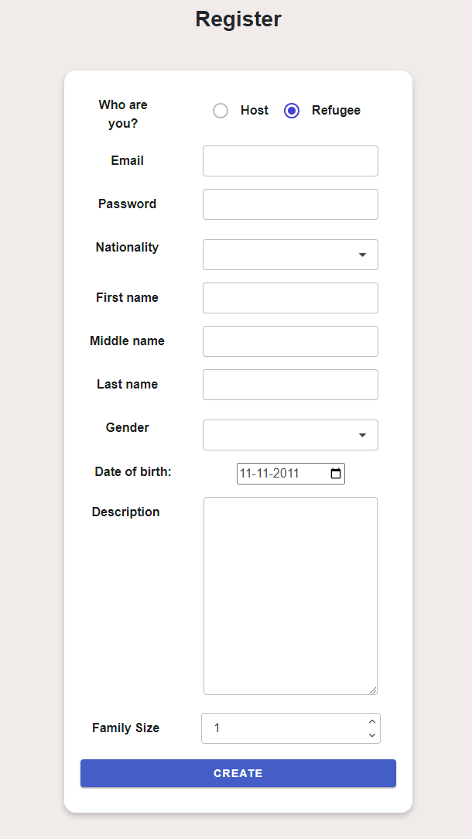

Once you are finished, simply click the *CREATE* button, and a pop up will appear indicating that registration was successful.

If any required fields[2] are not filled, or any other errors occur, a message will be shown in the bottom of the screen signifying this.

# Login

Pressing the *Login* button will take you to the login page, where you must fill in your email and password.

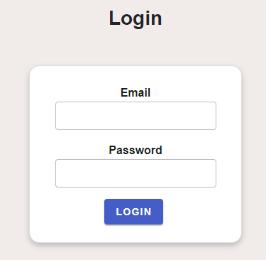

If the email and password entered does not match, or if the email entered is not connected to an account in the system, an error the following error will be shown

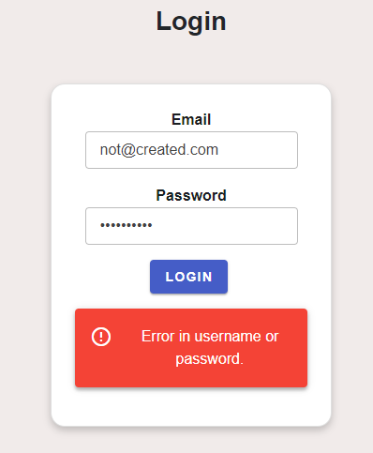

# Using the system as a host

After successfully logging in as a host, you will se that the navigation-menu has changed so that it now contains links to all actions you are able to perform in the system

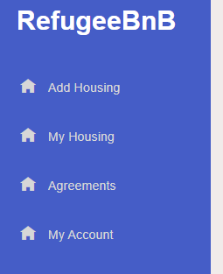

## Add Housing

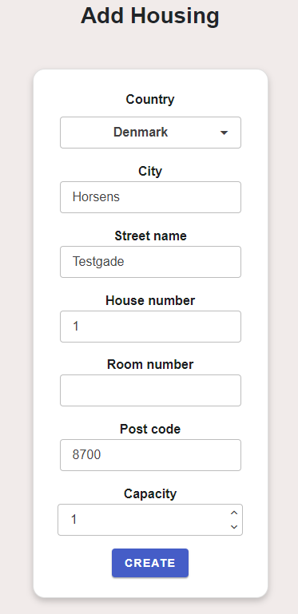Clicking here allows you to add housing to the system to provide accommodation for refugees.

Simply fill in the information needed[3] and click create to add the housing to the system.

After successfully adding housing to the system, a pop-up will appear, asking you to either add more housing, or to go to the overview of all added housing.

## My Housing

Clicking this will take you to an overview of all housing you are currently offering in the system.

If you currently have no housing added, you will see this message

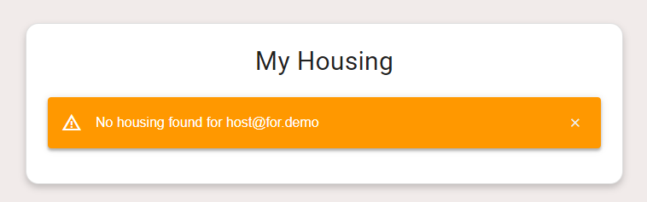

If you have added housing, you will be presented with a list of all your housing with the option to delete any housing that is available[4].

### Delete Housing

Pressing the delete button will remove the housing from the system, and a confirmation message will be shown.

## Agreements

Here you will see an overview of all agreements you are currently part of, both pending and accepted. For each pending agreement you can either decline or accept them, and for currently accepted agreements, you can cancel them.

## My Account

See *Shared: My account* further down

# Using the system as a refugee

After successfully logging in as a refugee, you will se that the navigation-menu has changed so that it now contains links to all actions you are able to perform in the system

## Display Housing

This is where you will be able to apply for an agreement by choosing available housing from the list.

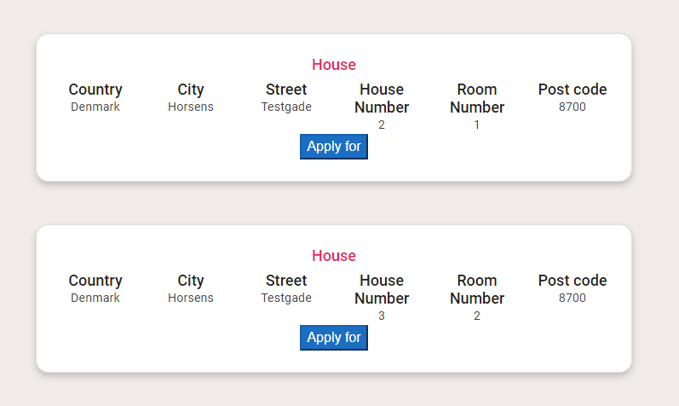

When you click *Apply for*, a confirmation window will be shown.

## Agreement

Here, you will see information about your current confirmed agreement if you have one.

If you do not currently have a confirmed agreement, a message will tell you that.

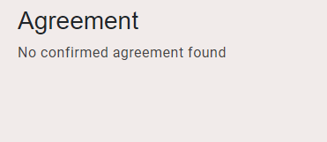

## My Account

See *Shared: My account* further down

# Shared: My Account

Clicking this will take you to the account page.

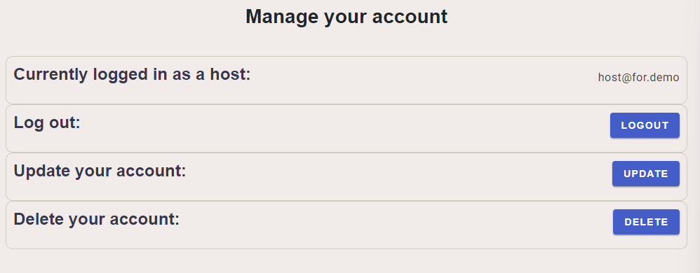

Here, you can log out, update your account, or delete your account.

## Update Account

Clicking this will take you to a page like the registration page, where you will have the option to update your information.

## Delete account

Pressing this will make a confirmation window appear asking if you are sure you want to delete your account. If you click DELETE ACCOUNT in this window, your account will be deleted from the system.[5]

1. All information, excluding your email-address, can be updated later.
2. Required fields are: Everything except Middle name and description (description is only available to refugees)
3. All fields except room number are required, if any required fields are empty, an error message will be shown
4. Available meaning that it is not currently included in any accepted agreements.
5. Unless you are part of an ongoing agreement, in which case an error will be shown.